Session 13 - 1
import java.util.*;

class Student {

private int id;
private String name;
private double cgpa;

public Student(int id, String name, double cgpa) {
this.id = id;
this.name = name;
this.cgpa = cgpa;
}

public int getID() {
return id;
}

public String getName() {
return name;
}

public double getCGPA() {
return cgpa;
}
}

class Priorities {

public List<Student> getStudents(List<String> events) {

PriorityQueue<Student> pq = new PriorityQueue<>(
(s1, s2) -> {

// 1. Higher CGPA first
int cgpaCompare = Double.compare(
s2.getCGPA(),
s1.getCGPA()
);

if (cgpaCompare != 0) {
return cgpaCompare;
}

// 2. Name in alphabetical order
int nameCompare = s1.getName().compareTo(
s2.getName()
);

if (nameCompare != 0) {
return nameCompare;
}

// 3. Smaller ID first
return Integer.compare(
s1.getID(),
s2.getID()
);
}
);

for (String event : events) {

String[] parts = event.split(" ");

if (parts[0].equals("ENTER")) {

String name = parts[1];
double cgpa = Double.parseDouble(parts[2]);
int id = Integer.parseInt(parts[3]);

pq.add(new Student(id, name, cgpa));

} else if (parts[0].equals("SERVED")) {

if (!pq.isEmpty()) {
pq.poll();
}
}
}

List<Student> result = new ArrayList<>();

while (!pq.isEmpty()) {
result.add(pq.poll());
}

return result;
}
}

public class Solution {

private final static Scanner scan = new Scanner(System.in);

public static void main(String[] args) {

int totalEvents = Integer.parseInt(
scan.nextLine().trim()
);

List<String> events = new ArrayList<>();

while (totalEvents-- != 0) {
String event = scan.nextLine();
events.add(event);
}

Priorities priorities = new Priorities();

List<Student> students =
priorities.getStudents(events);

if (students.isEmpty()) {
System.out.println("EMPTY");
} else {
for (Student student : students) {
System.out.println(student.getName());
}
}

scan.close();
}
}
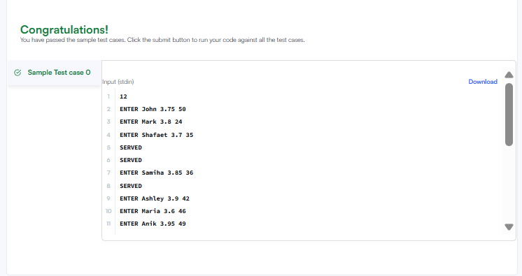

Session 13 -2

import java.io.*;
import java.util.*;

public class Solution {

public static void main(String[] args) {

Scanner sc = new Scanner(System.in);

// Number of lines
int n = sc.nextInt();

// ArrayList containing ArrayLists
ArrayList<ArrayList<Integer>> lines = new ArrayList<>();

// Read each line
for (int i = 0; i < n; i++) {

// Number of integers in this line
int d = sc.nextInt();

ArrayList<Integer> list = new ArrayList<>();

// Read the integers
for (int j = 0; j < d; j++) {
list.add(sc.nextInt());
}

// Add this line to the main ArrayList
lines.add(list);
}

// Number of queries
int q = sc.nextInt();

// Process queries
for (int i = 0; i < q; i++) {

int x = sc.nextInt();
int y = sc.nextInt();

// Convert 1-based positions to 0-based indexes
if (x >= 1 && x <= lines.size()
&& y >= 1 && y <= lines.get(x - 1).size()) {

System.out.println(
lines.get(x - 1).get(y - 1)
);

} else {
System.out.println("ERROR!");
}
}

sc.close();
}
}

